Specification
  - Release limits purchase order
Doc Version 1.1

Customer: | Deutsche Windtechnik
Project: | German Wind Technology Ongoing Support
proALPHA version: | 7.1e
proALPHA installation(s): | DE
GUI language: | German
Author: | Benedikt Giese (übernommen + ergänzt)
Created on: | 30.01.2025
Last change on: | 19.06.2026
Contact person customer: | Jens Finzel (DWT)

This document describes a customization or extension of the proALPHA standard software and has been checked by the customer. The technical design in Chapters 2 - 4 is hereby released in compliance with the requirements of the "Final Provisions" section of the technical specification and costing:

............................................
Date and signature customer

Contents
1. [UPDATE THE TABLE] 3
1.1 [UPDATE THE TABLE] 3
1.2 [UPDATE THE TABLE] 3
1.3 [UPDATE THE TABLE] 3
1.4 [UPDATE THE TABLE] 3
2. [UPDATE THE TABLE] 4
2.1 [UPDATE THE TABLE] 4
2.1.1 [UPDATE THE TABLE] 4
2.2 [UPDATE THE TABLE] 5
3. [UPDATE THE TABLE] 6
3.1 [UPDATE THE TABLE] 6
4. [UPDATE THE TABLE] 8
4.1 [UPDATE THE TABLE] 8
4.2 [UPDATE THE TABLE] 8
4.3 [UPDATE THE TABLE] 8
5. [UPDATE THE TABLE] 9
5.1 [UPDATE THE TABLE] 9
5.1.1 [UPDATE THE TABLE] 9
5.1.2 [UPDATE THE TABLE] 9
5.1.3 [UPDATE THE TABLE] 9
6. [UPDATE THE TABLE] 10
7. [UPDATE THE TABLE] 11
7.1 [UPDATE THE TABLE] 11
7.2 [UPDATE THE TABLE] 11
8. [UPDATE THE TABLE] 12

Requirements

References
As part of the optimization project of the DWT KG (company 171), the purchase request in the Purchasing department came up.

Summary and objective
The Purchasing department has release limits for net purchases that depend on groups of people.
The wish is to have a simple reference in the purchase order lines that indicates to a specialist that the net purchase has been exceeded and that a release by a second person is required.

Request Description
The net purchase is to be highlighted in red in the purchase order lines, exactly when the purchase order value from an ACM parameter has been reached or exceeded.
ถ้ายอดซื้อเกิน field Warenwert จะถูกไฮไลต์สีแดงเมื่อ Warenwert มีมากกว่าหรือเท่ากับค่าที่ ACM กำหนดไว้

Request Glossary (Term Statement)

Term | Explanation
Table 1: request glossary

Professional design

Solution description

Release limits net purchase

Business logic & GUI
In a new company-specific ACM parameter suggestion: "X_Net Purchase" (the exact description of the ACM parameter is defined by the development), an amount is entered (for example 30,000). This value is also completely independent of a currency.
สร้าง ACM Parameter เฉพาะของบริษัท โดยโจทย์แนะนำให้ตั้งชื่อว่า "X_Net Purchase" ค่าที่ใส่ใน Parameter นี้จะเป็นเพียงตัวเลข เช่น 30,000 โดยไม่สนว่าจะเป็นสกุลเงินอะไร
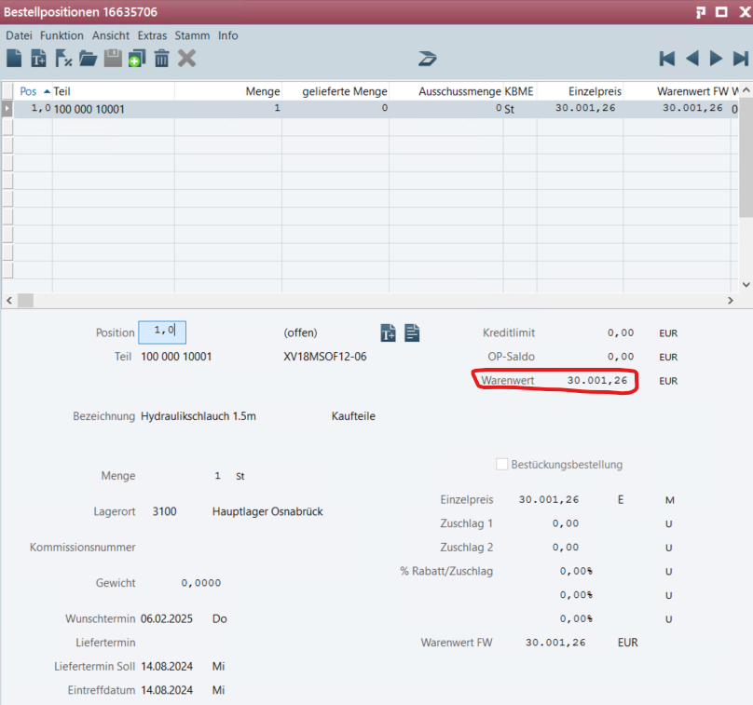
Figure 1 Net Purchase field in the purchase order line
As soon as the net purchase reaches or exceeds the value defined in the ACM parameter, the "Net Purchase" field is to be highlighted in red in all purchase order lines of the purchase order.
The red selection is to color the field in analogy to the minimum order value that is not reached (standard functionality):
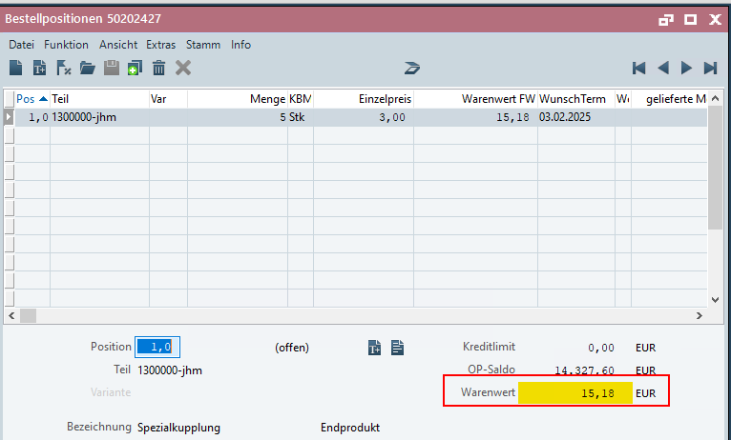
Figure 2 Yellow selection when the minimum order value is not reached
If the net purchase falls below the value defined in the ACM parameter, the "Net Purchase" field is no longer to be highlighted in red in all purchase order lines of the purchase order.
If the net purchase is less than the minimum order value (yellow selection from the standard) & the release value from the new ACM parameter has been exceeded (red selection of this modification), the red selection is to be defined & not the yellow one.
If the "X Net Purchase" ACM parameter is set to 0, the previously implemented proALPHA standard is to apply.
- กรณีเกินเพดาน (Net Purchase >= ACM Parameter): ช่อง "Net Purchase" ใน ทุกบรรทัด (All lines) ของใบสั่งซื้อใบนั้น จะต้องถูกไฮไลท์เป็น สีแดง (Red)
- กรณีไม่เกินเพดาน (Net Purchase <= ACM Parameter): ช่อง "Net Purchase" จะกลับมาเป็นสีปกติ (เอาสีแดงออก)
- สวิตช์เปิด-ปิดระบบ: ถ้าตั้งค่า ACM Parameter X_Net Purchase = 0 ให้ถือว่าปิดระบบนี้ไปเลย และให้หน้าจอทำงานตามมาตรฐาน (Standard) ของ proALPHA ปกติ

Data model
Company-specific ACM parameter, suggestion: "X_Net Purchase" (the exact description of the ACM parameter is defined by the development) with initial value 0.

Output
No output required.

Accruals and deferrals
The adjustment refers to the tables, fields and programs mentioned.
Functional extensions are not automatically made to adjoining modules of the proALPHA environment, such as DMS, Analysers, reports and forms, with this specification. The proALPHA Help is not automatically extended either.
Changes to adjoining modules/programs have to be described and defined in the functional specifications.

Test cases
The specified test cases map the adjustment described here and are the basis for the acceptance of the software.

Release limits purchase order
Pt | Explanation | Expected result | Test data
 | The purchase order is created with several purchase order lines. The net purchase exceeds the value from the new ACM parameter | The net purchase is highlighted in red in all purchase order lines. | ACM parameter is set to 30,000.
 | Test result (incl. screenshots)
 | The purchase order falls below the net purchase from the ACM parameter, e.g. by deleting a purchase order line or changing a price. | The net purchase is no longer highlighted in red in all purchase order lines. | ACM parameter is set to 30,000.
 | Test result (incl. screenshots)
 | New purchase order for a supplier with a defined minimum order value above €30,000 | The net purchase is highlighted in yellow because the minimum order value is not reached.
 | Test result (incl. screenshots)
 | Creation of lines so that the net purchase is above the value from the ACM parameter but below the minimum order value. | The net purchase is highlighted in red because the value limit overrides the minimum order value.
 | Test result (incl. screenshots)

Prerequisites

Technical requirements
The use of proALPHA functionalities outside the Concurrent User Model (connection of external systems, background processing) requires the licensing of so-called software services.
"Use of proALPHA functionalities" refers to any use or access to the proALPHA infrastructure, e.g.
- Writing in data structures of proALPHA
- Calling proALPHA classes and other business logic
- Opening proALPHA Services
The following software services are therefore required for the implementation described in the functional specification:
- <List services here, otherwise delete section>
- ...

Organizational requirements

Notes about the commissioning

Technical design

Su 2.1.1 Release limits net purchase

GUI
Red color of the net purchase if the ACM value is exceeded

Business logic

{Fnr
pa_lUISvcSetWidgetColor
"gdNet Purchase:handle in frame {&FRAME-NAME},
'DM_WarningBGColor,DM_WarningFGColor':U"}.

{Fnr
pa_lUISvcSetWidgetColor
"gdNet Purchase:handle in frame {&FRAME-NAME},
'DM_ColorPool_red_1,DM_DataDisplayFGColor':U"}.

If the net purchase exceeds the ACM, this is highlighted in red, even if the minimum order value has been exceeded, otherwise standard logic

Data model
New ACM XE_NetPurchase, integer

Final provisions
This specification forms the basis for customer-specific extensions of the proALPHA® ^{standard} software.
The customer-specific extensions only cover the category defined in this specification. Functionality beyond this scope is not provided.
Unless expressly agreed otherwise, the customer-specific extensions are only created in German: no programs, program parts or data are translated into other languages. This also applies to the languages supported by proALPHA® in the standard version.
The customer-specific expansions are carefully tested before they are delivered. However, for technical reasons, it is not possible to perform the test under the same conditions and with the same data that will be used by the customer. It is therefore recommended to carefully check the functions after they have been delivered in the real system environment.
The customer is aware that variances in the display details or handling of the functions defined in this specification may be required for the transfer of the functions to new versions of proALPHA®. This specification also remains valid in this case, provided that there is a maintenance agreement for the customer-specific extensions defined in this specification and no changes to the functionality have to be agreed on.
This specification documents the customer-specific expansions. No other documentation beyond that contained in this SOW shall be provided. Questions about customer-specific expansions are received and forwarded by the hotline.
By signing on page 1, you confirm:
that the specification is accepted in this version and becomes part of the contract,
This specification defines the functional scope of the software to be created and there are no side agreements regarding the functionality.

Appendix

Table of Figures
[UPDATE THE TABLE] 4
[UPDATE THE TABLE] 5

Table of tables
[UPDATE THE TABLE] 3

Change history
Doc -  Version | Date | Contact | initiator | Chapter | Explanation
1.0 | 17.01.2025 | Benedikt Giese (übernommen + ergänzt) | Jens Finzel (DWT) | All | Initial new entry
1.1 | 03.02.2025 | Benedikt Giese (übernommen + ergänzt) | Jens Finzel (DWT) | All | Revision and finalization

